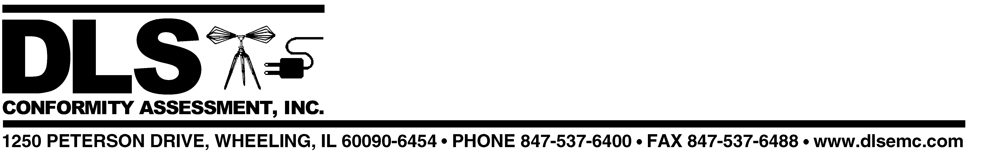

January 7, 2003

Mr. Kenn Gordon

Fullplay Media Systems, Inc.
12600 SE 38th Street Suite 150
LaGrange Park, IL 60526

Subject: Updated Quote for Evaluation, Testing and Certification (UL/cUL)

Products: IMS 1.5 (preliminary model designation)

Requirements: UL 6500:1999; CSA E60065-2000

Dear Kenn:

As discussed yesterday by phone, your company has decided to use UL rather than TUV Rheinland for North American certification of the new IMS device. This quote is a revised version of the one we issued on December 19, 2002 to cover North American certification only (no CE marking) by TUV.

When I contacted Charles Kelley at UL to obtain an estimate for UL costs, he was not able to supply one, citing a lack of information about the new unit. Since it is electrically very similar to the already Listed version, I had assumed that the UL cost should be about the same or less than that for the original unit. For this reason I estimated $5000 for UL as a worst case for the budgetary quote sent to David Dancause in November, 2000 (copy attached).

In the absence of any updated number from UL, I’m going to stick with that estimate here, although I think that it will be lower once we have given UL the documentation that they say is needed to determine their cost. See Items 1-4 below.

UL estimated cost $5000.00
DLSCA estimated cost $3000.00

Total Estimated Cost $8000.00

This estimated cost includes testing and certification activities for both of the standards cited above. It also includes reasonable consulting time as necessary to identify and correct non-compliant items requiring modification in order to meet the standards. If additional or repeated
testing is required as a result of modifications made during the course of the project, additional cost may be incurred; we would of course advise you in advance of applying any additional charges.

We need to provide the following information to UL ASAP.

- Verification that this new unit uses the same laser as that in the UL Listed LVS 1000. If it does not use the same scanner and circuitry, we’ll need specifications for the one you are using.
- Schematic(s) for the new version
- Specifications for the inverter used to supply voltage for backlighting of the LCD display, or a contact name and phone number of the rep that can supply this information.
- Identification of the enclosure plastic material (material manufacturer, type and grade designation). As discussed with you previously, molded enclosure samples can be supplied for mechanical testing after electrical testing has been completed.

Charles Kelley verified that an impact test would be required on the new enclosure and display. This test can be done easily and quickly at some point after the other electrical testing and evaluation has been conducted, if final enclosure samples are not available right away. In order to minimize potential delays, we recommend that other testing be done earlier so that completion of the project can be expedited and a Notice of Authorization issued by UL as soon as the test is successfully conducted.

In order to simplify paperwork for you, a single P.O. can be issued to DLS Conformity Assessment for the above amount. We will then invoice you for both UL and DLS charges.

Please feel free to contact me if you have questions or concerns regarding the above. We look forward to working with you again.

Best Regards,
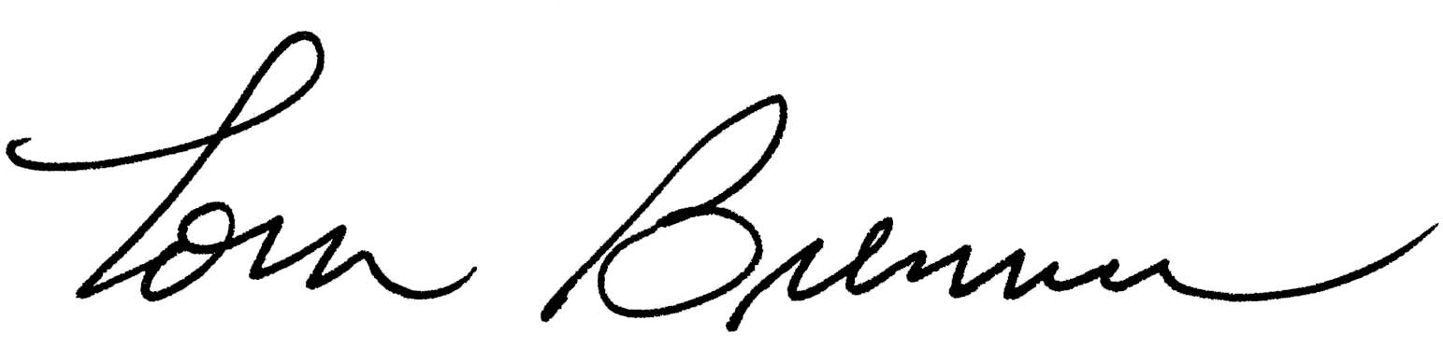
Tom Brenner

Manager – Product Safety
D.L.S. Conformity Assessment, Inc.
tbrenner@dlsemc.com

*SUBJECT TO THE ATTACHED TERMS AND CONDITIONS. The liability of D.L.S. Electronic Systems, Inc. with respect to the goods and services charged for herein shall in no event exceed the paid amount of this notice.

D.L.S. Conformity Assessment, Inc. is a wholly owned subsidiary of D.L.S. Electronic Systems, Inc.
All Orders are accepted and all reports and certificates issued subject to the General Conditions for Inspection and Testing Services (copy available upon request).

